# ELECTRONICS CIRCUIT LAB

**LAB NO 6**



**Spring 2020**

Submitted by: **Shah Raza**

Registration No. : **18PWCSE1658**

Class Section: **B**

“On my honor, as a student of University of Engineering and Technology, I have neither given nor received unauthorized assistance on this academic work.”

Submitted to:

**Engr. Abdullah Hamid**

Friday, 7 July, 2020

**Department of Computer Systems Engineering**

**University of Engineering and Technology, Peshawar**

## Clippers

## Objectives:

## To calculate and measure the output voltages of Parallel & Series clipper circuits.

## Equipment:

* Oscilloscope
* Function Generator
* Digital Multimeter (DMM)
* DC power supply

## Components:

## Diode: Silicon (D1N4002)

## Resistors: 2.2kΩ, 3.3kΩ

## EXPERIMENT:

**Clipper:**

## a clipper is a device designed to prevent the output of a circuit from exceeding a predetermined voltage level without distorting the remaining part of the applied waveform.

**Parallel Clippers:**

In parallel clipper, diode is in parallel to the load.

During positive half cycle of input voltage is positive therefore diode is forward

biased and act as closed switch hence all the current flows through the diode and no voltage drop across

the output and output is zero. During negative half cycle input voltage is negative hence diode is reverse

biased and act as open switch hence there is direct connection between input and output

**Positive Parallel Clipper:**

## Procedure:

Make the connections as shown in the figure below.

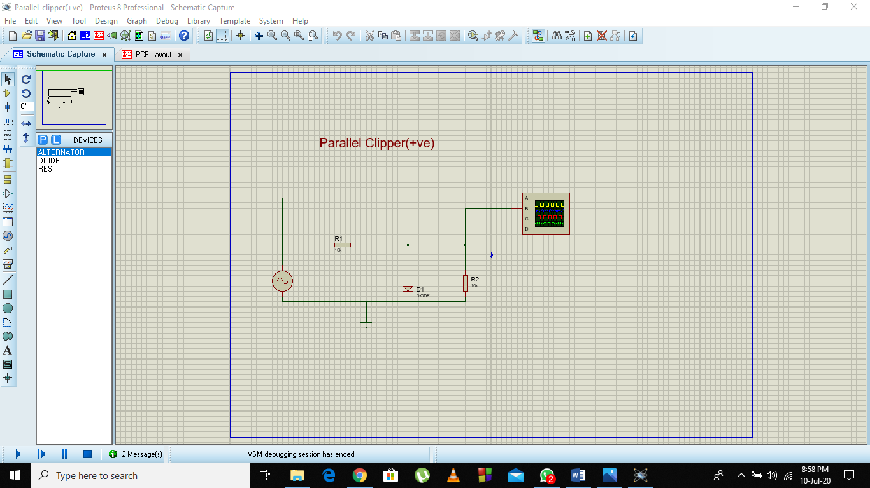

## PCB Layout:

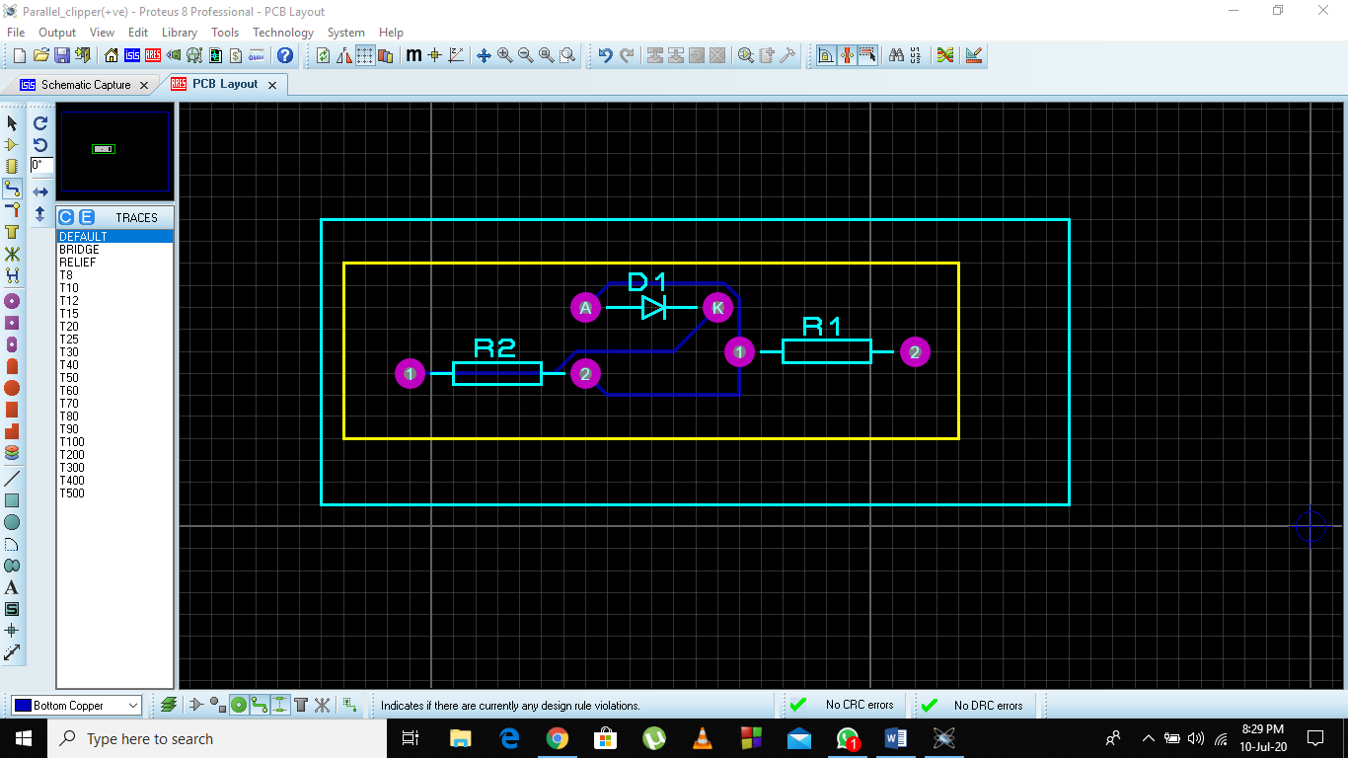

## Output:

The output of oscilloscope is as follows.

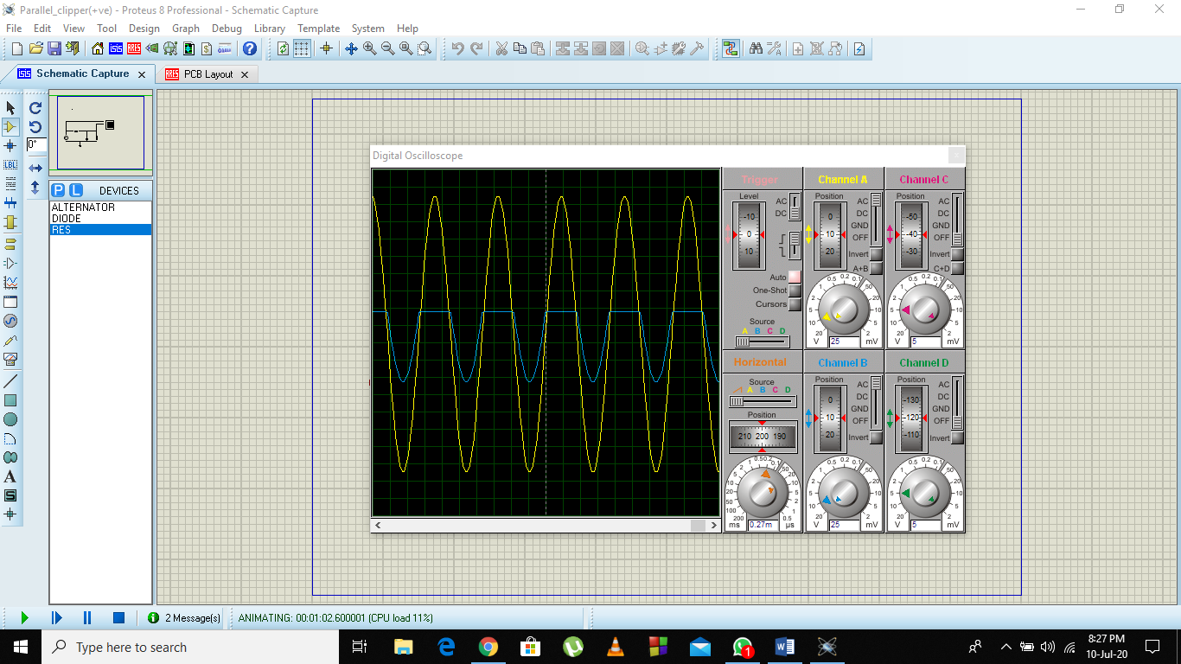

**Negative Parallel Clipper:**

## Procedure:

Make the connections as shown in the figure below.

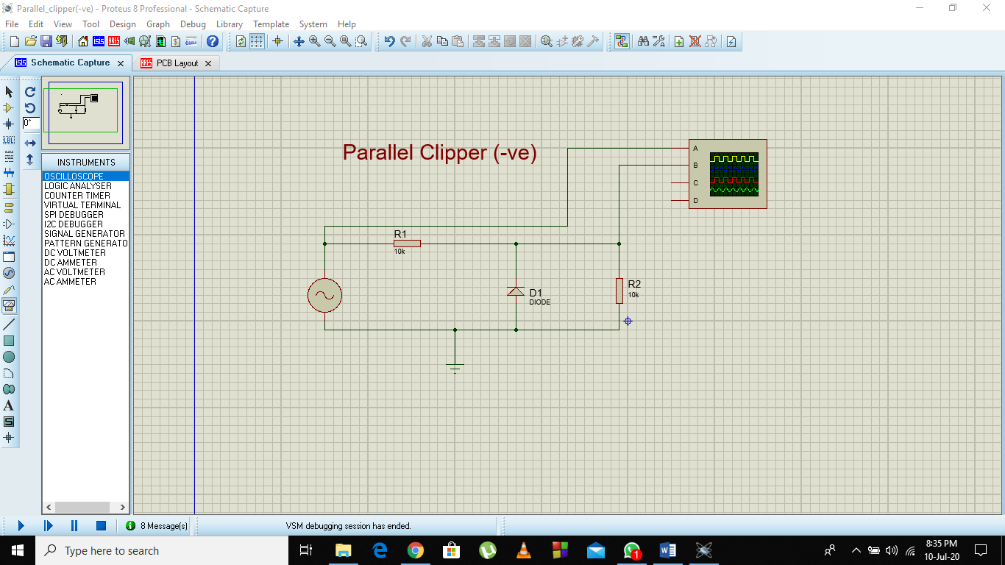

## PCB Layout:

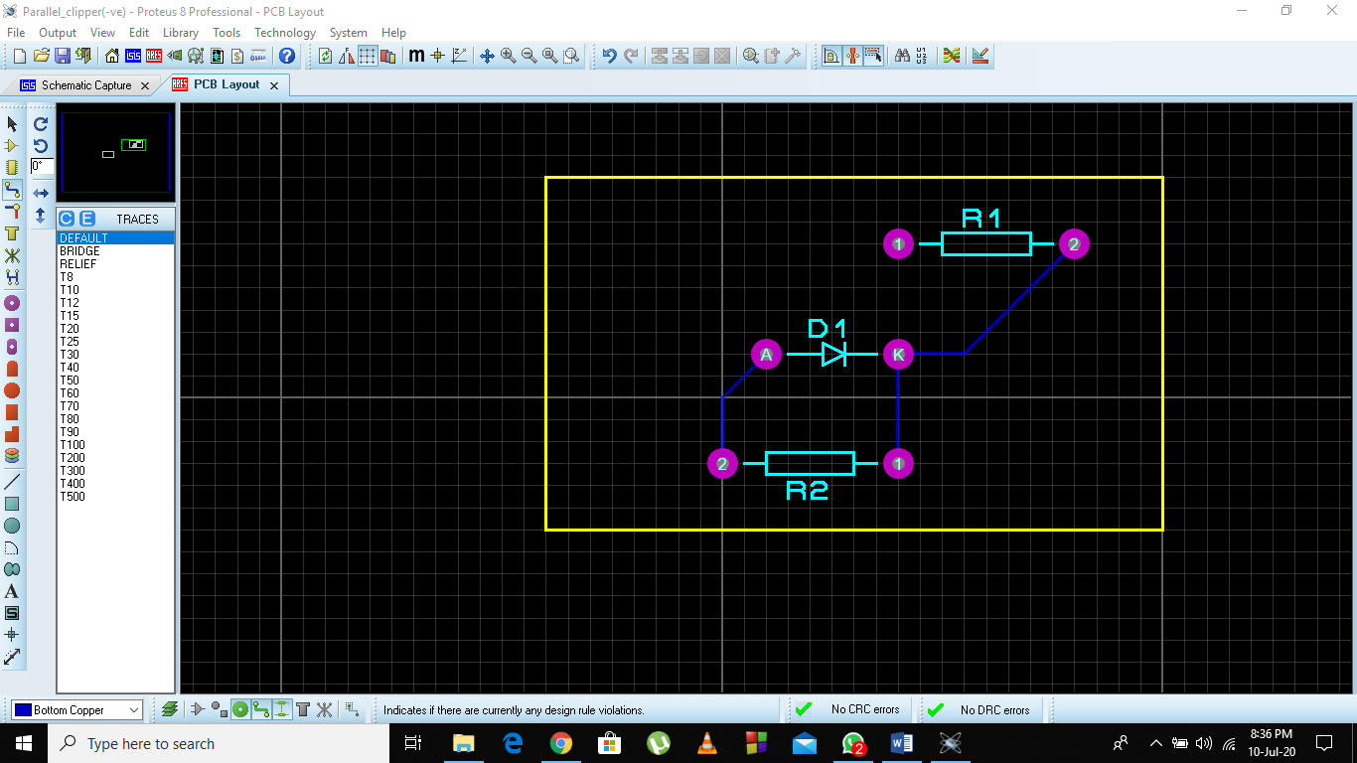

## Output:

The output of oscilloscope is as follows.

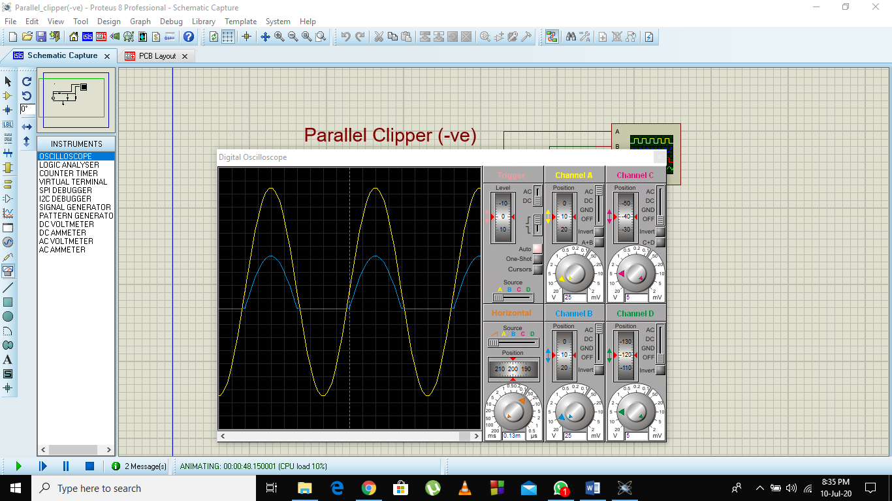

**Parallel Biased Clipper:**

## Procedure:

Make the connections as shown in the figure below.

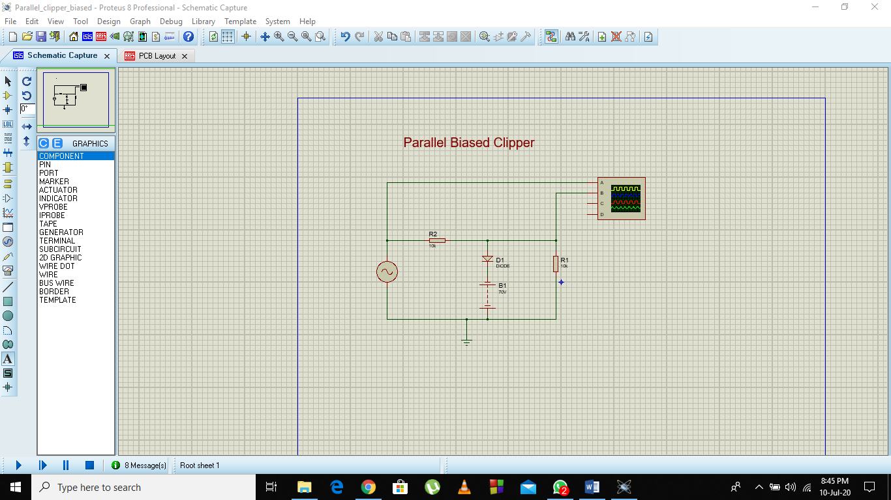

## PCB Layout:

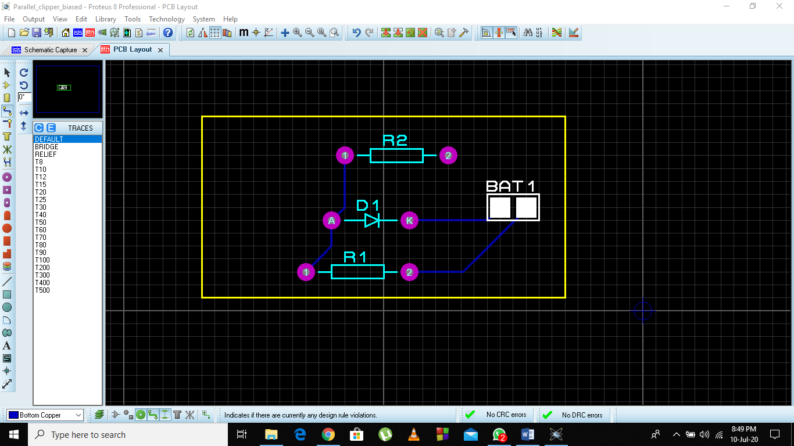

## Output:

The output of oscilloscope is as follows.

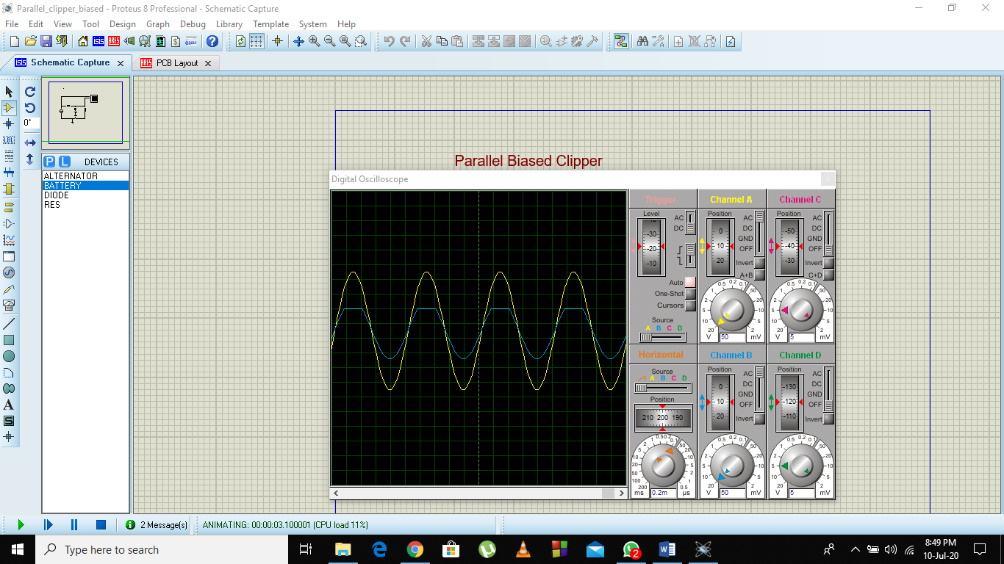

## Series Clipper:

In series clipper, diode is connected in series with the load.

During positive half of cycle input voltage is positive therefore diode is reversed

biased and act as open circuit hence output is zero. During negative half input voltage is negative, diode is

forward biased and act as a closed switch and hence all the input voltage drop appear across the resistor.

**Positive Series Clipper:**

## Procedure:

Make the connections as shown in the figure below.

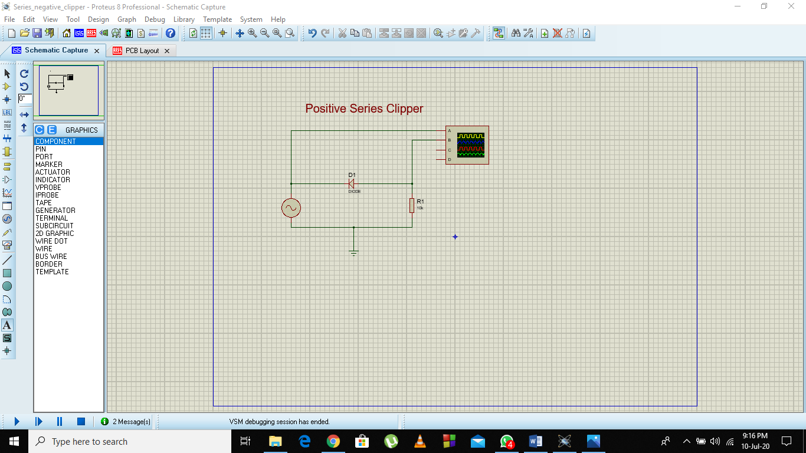

## Output:

The output of oscilloscope is as follows.

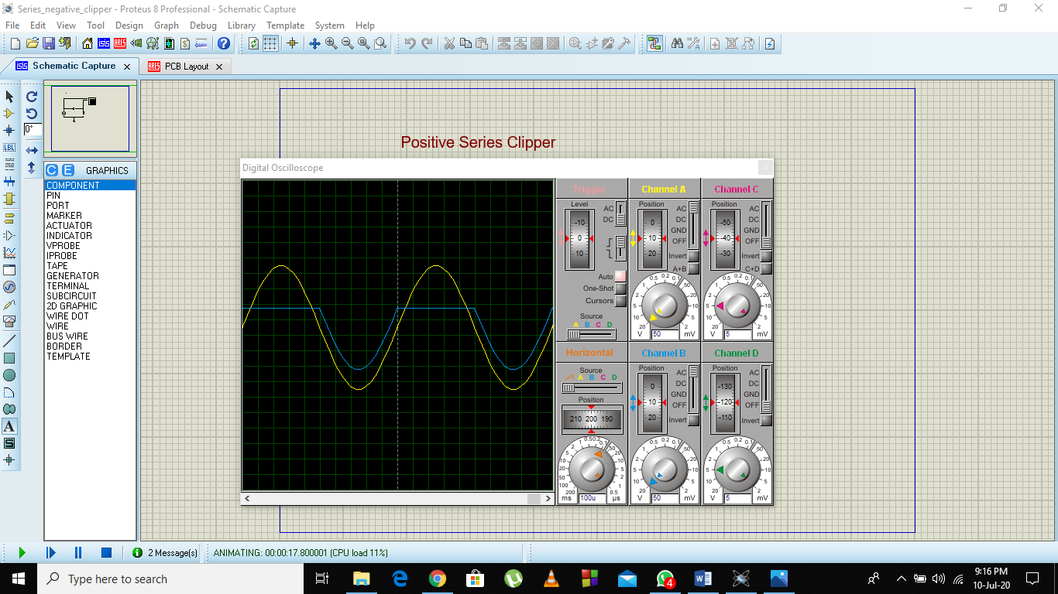

## PCB Layout:

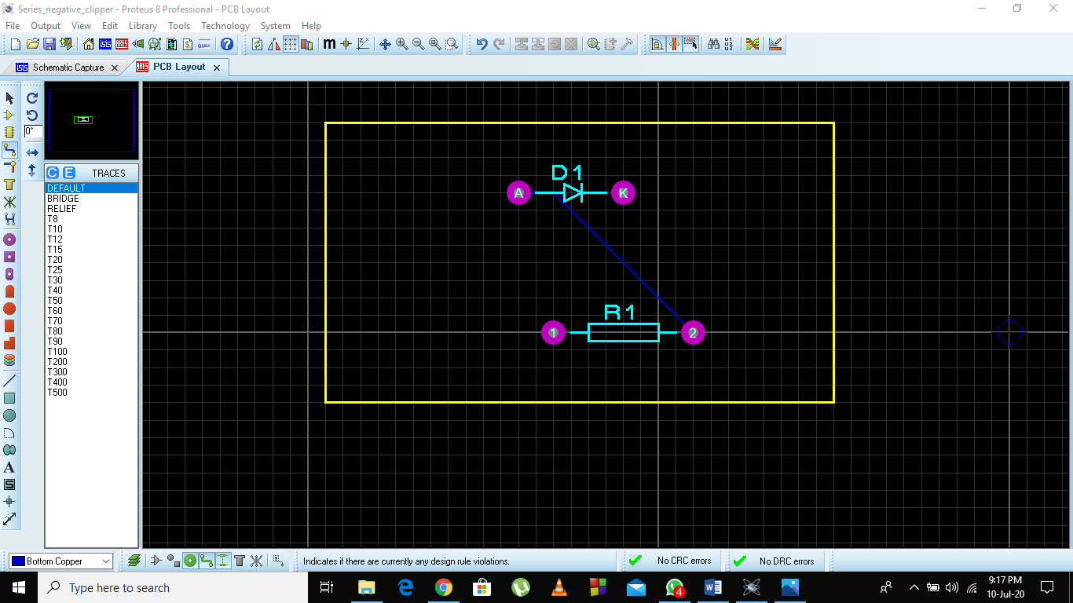

**Negative Series Clipper:**

## Procedure:

Make the connections as shown in the figure below.

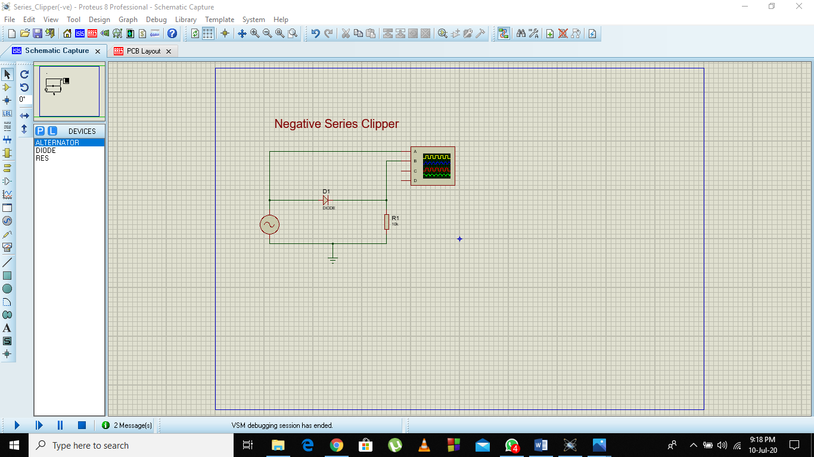

## PCB Layout:

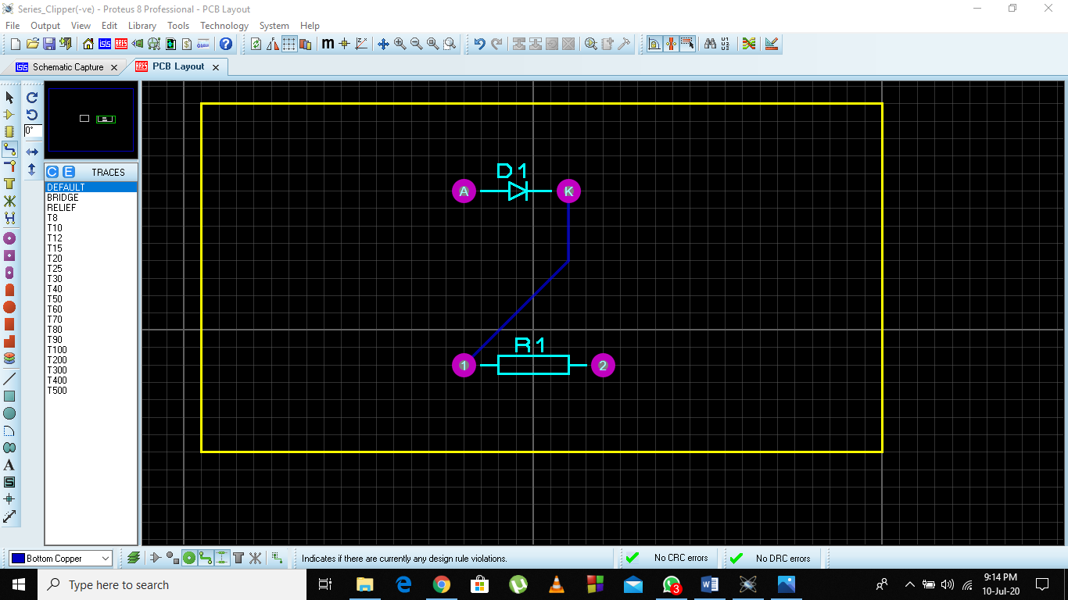

## Output:

The output of oscilloscope is as follows.

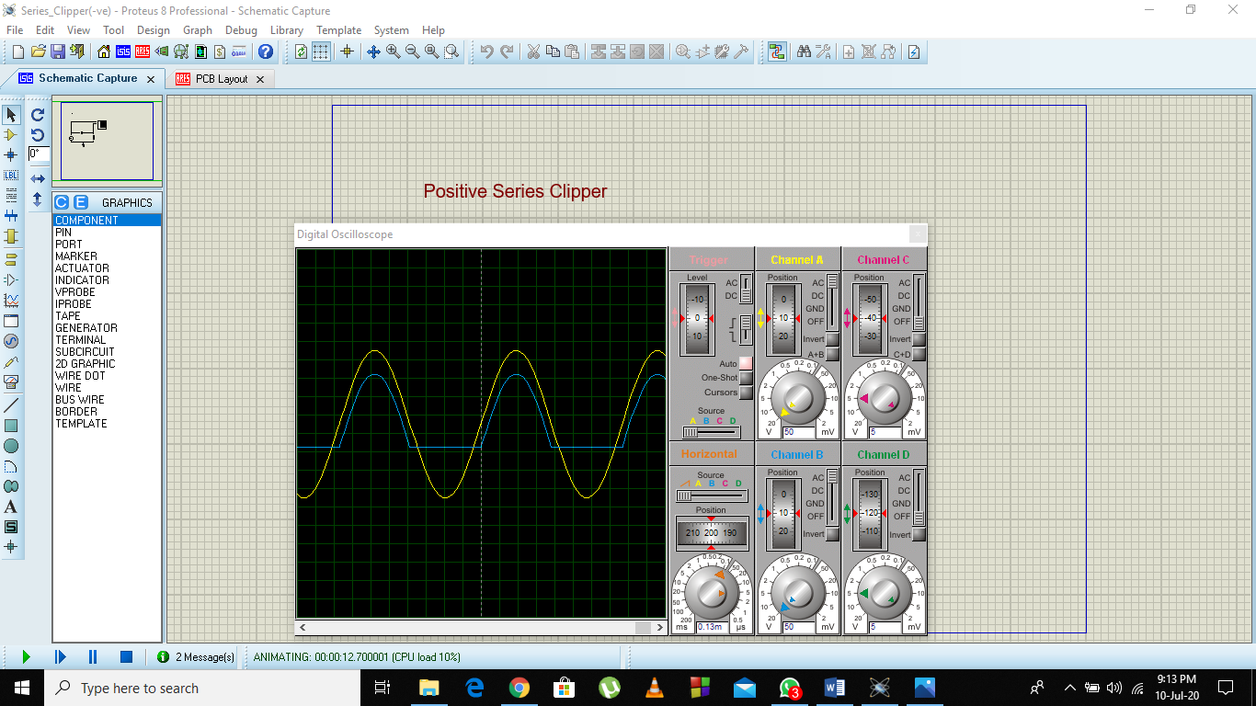

**Series Biased Clipper:**

## Procedure:

Make the connections as shown in the figure below.

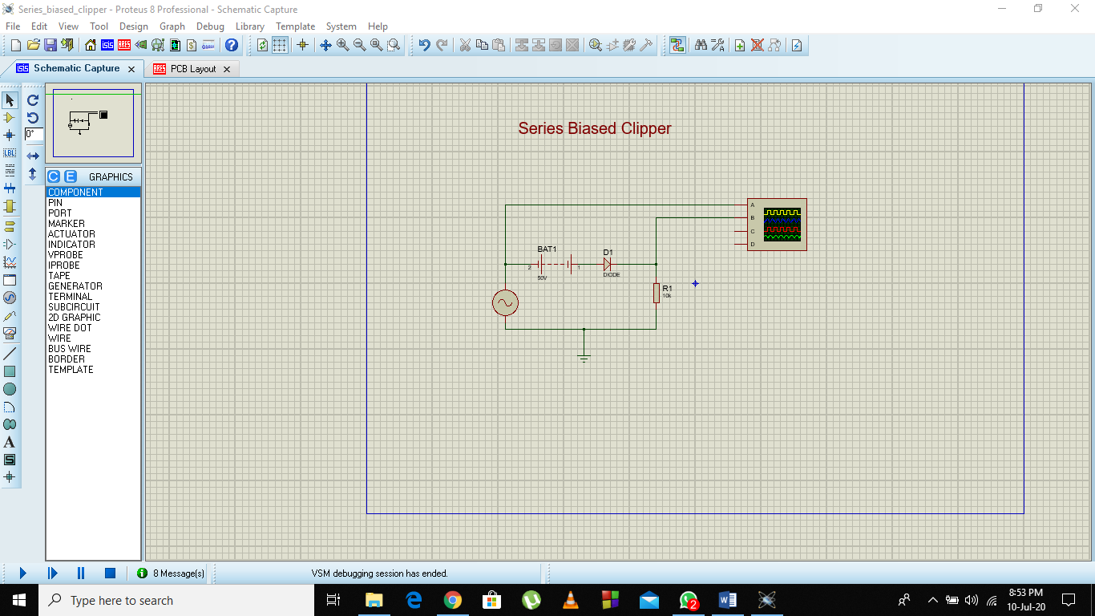

**PCB Layout:**

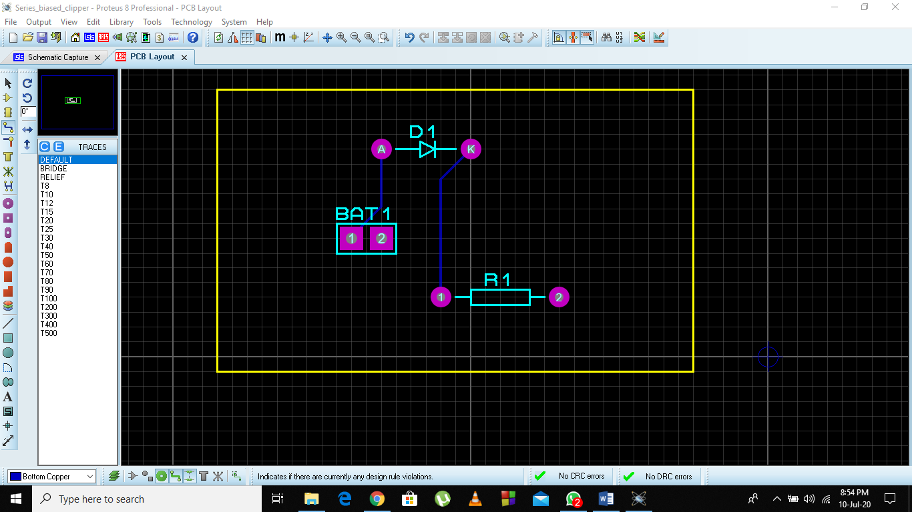

## Output:

The output of oscilloscope is as follows.

